STEP -1 EMIS LOGIN USING SCHOOL ID & PASSWORD
STEP -2 SELECT ONLINE SERVICES IN THE MENU
STEP -3 IN THE SCHEMES DISPLAY SELECT SPECIAL CASS INCENTIVE
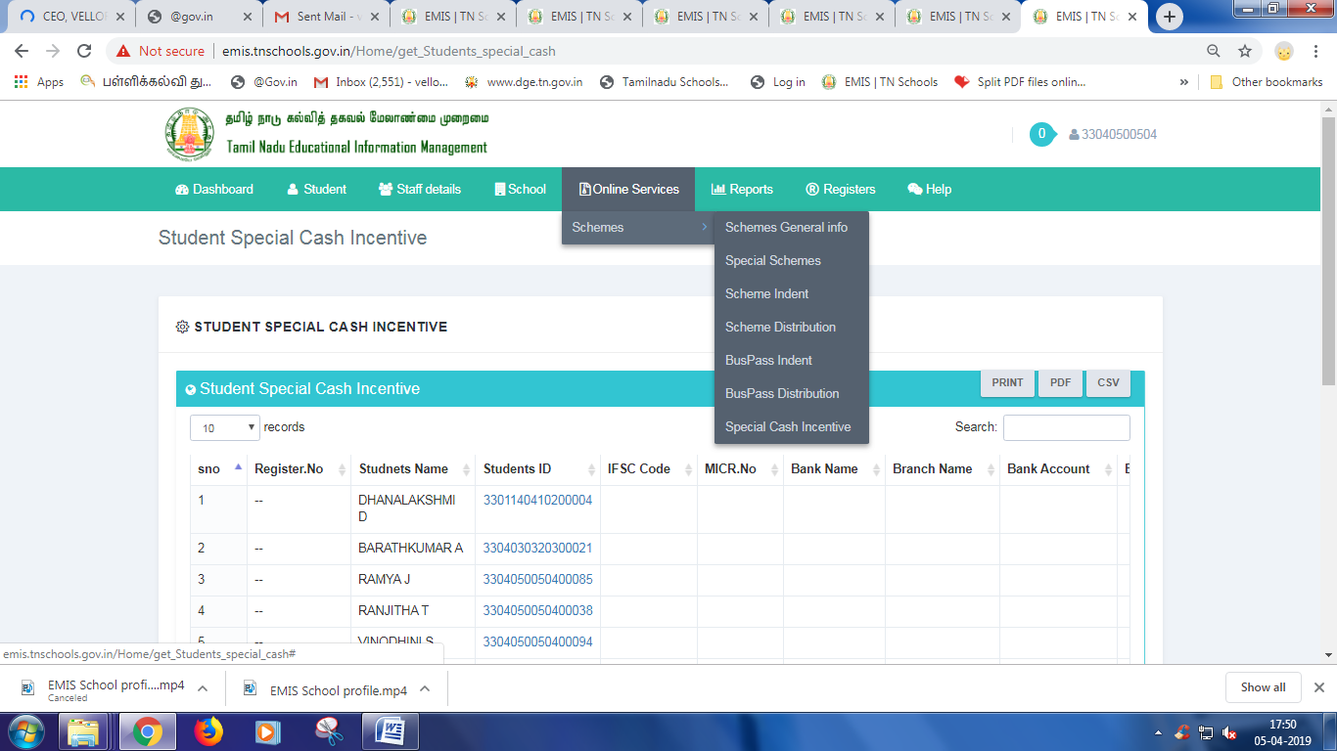
STEP -4 12TH STD STUDENT LIST WILL BE DISPLAYED
STEP - 5 CLICK ON STUDENTS ID GIVEN IN BLUE COLOUR
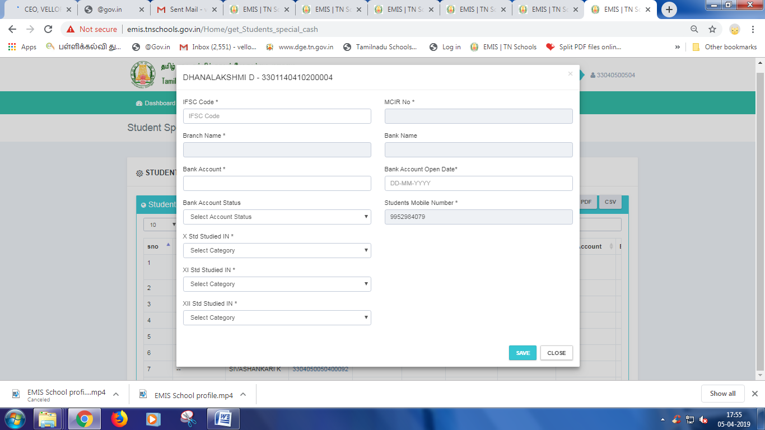
STEP - 6 FILL UP ALL FIELDS IN THE FORM
CHECK UP ALL THE FIELDS ENTERED INTO THE FORM ONCE AGAIN AND CONFIRM
STEP -7 CLICK THE SAVE BUTTON TO SAVE THE FORM

