SYLLABUS FOR UNIT - III 10TH AND 12TH STANDARD
தமிழ்
மாதம் | செய்யுள் | உரைநடை | து.பாடம் | மொழிப்பயிற்ச்சி
அக்டோபா் | பாண்டியன் பரிசு  சிற்றிலக்கியங்கள் (அ - ஈ) | 5 6 | 7 8 | நாடகம் எழுதுதல்  கொச்சைசொற்கள்  நீக்கி எழுதுதல்

ENGLISH
MONTH | PROSE | POEM | S.READER | LEXICAL  COMPETENCIES | GRAMMAR | PAPER II
OCTOBER | 5 | 5 | 5 | Word formation, word building, Clipping& blending, relative ronounds using phrase/preposition in sentences, registers-Syllables, Homophones, Same words in different parts of speech, Auxiliaries, Modals and Quasi modals.

MATHEMATICS
MONTH | CHAPTER
OCTOBER | 7.APPLICATIONS OF INTEGRAL CALCULAS  9.DISCRETE MATHEMATICS

PHYSICS
MONTH |  | CHAPTER
OCTOBER |  | UNIT 7 AND UNIT 8
CHEMISTRY
MONTH | CHAPTER
OCTOBER | f BLOCK ELEMENTS, CO ORDINATION CHEMISTSRY AND NUCLERAR CHEMISTRY , Chemistry in Action

BIOLOGY
MONTH | CHAPTER
OCTOBER | BIO BOTANY | 5.PLANT PHYSIOLOGY
 | BIO ZOOLOGY | 5.ENVIRONMENTAL SCIENCE

BOTNAY
MONTH | CHAPTER
OCTOBER | 5.PLANT PHYSIOLOGY

ZOOLOGY
MONTH | CHAPTER
OCTOBER | 5.ENVIRONMENTAL SCIENCE  APPLIED BIOLOGY UPTO EPICULTURE

COMPUTER
MONTH | CHAPTER
OCTOBER | 6,7 AND 9

COMMERCE
MONTH | CHAPTER
OCTOBER | 6.STOCK EXANGE  7.COOPERATIVES

ACCOUNTANCY
MONTH | CHAPTER
OCTOBER | 7.PARTNERSHIP ACCOUNTS ADMISSION  8.PARTNERSHIP ACCOUNTS RETIREMENT

ECONOMICS
MONTH | CHAPTER
OCTOBER | 8 ,9 AND 10

HISTORY
MONTH | CHAPTER
OCTOBER | 26 TO 30

 | SSLC
TAMIL | 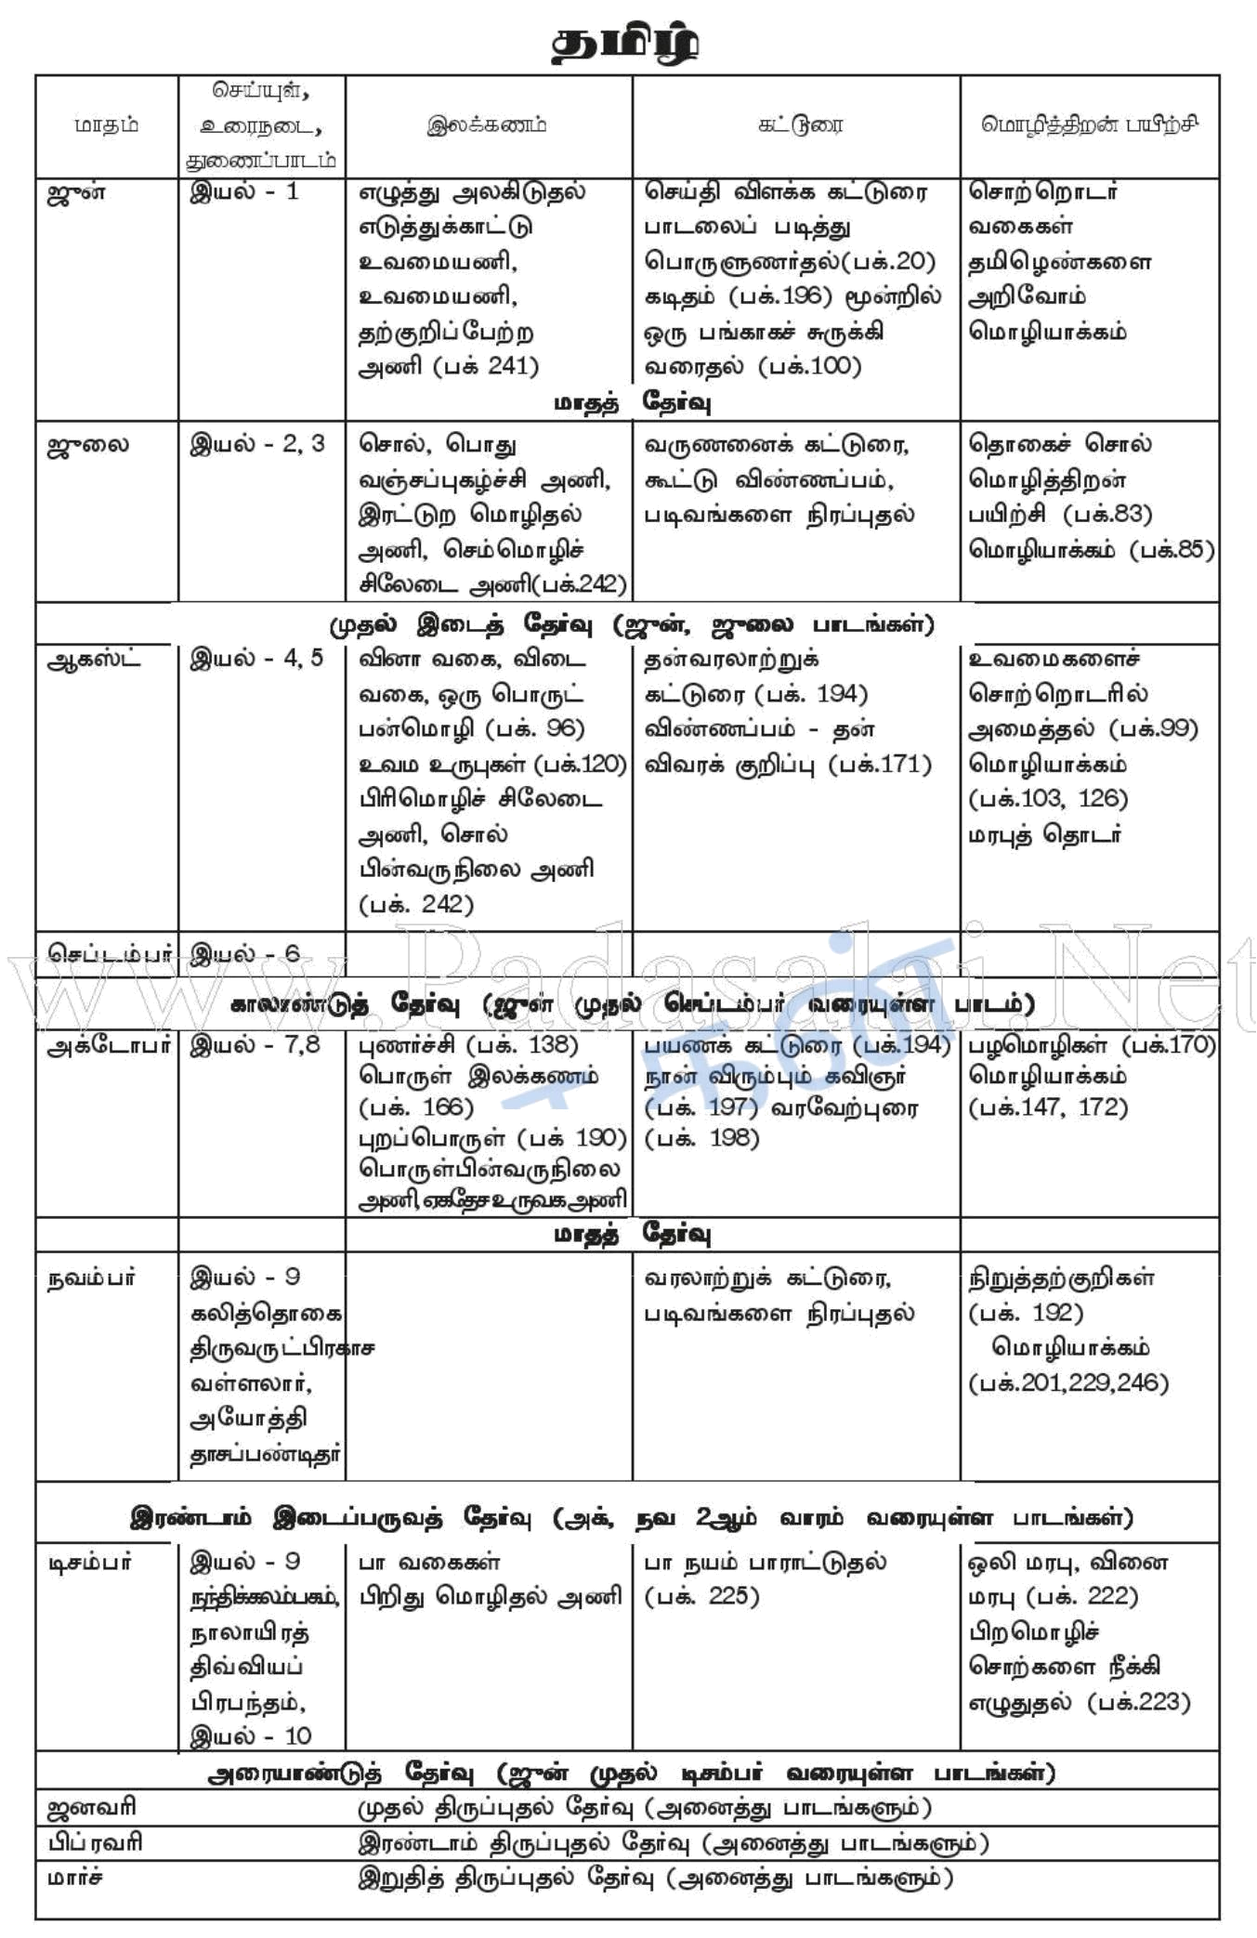
ENGLISH | CHAPTER V
MATHS | 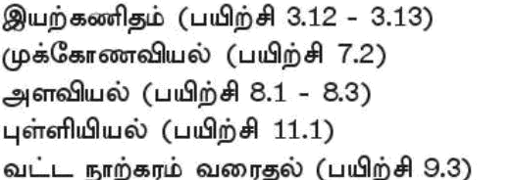
SCIENCE | PHYSICS -17 | CHEMISTRY-11 | BIOLOGY 4,5
SOCIAL | 

